**RESUME**

|  |
| --- |
| **Personal Details** |

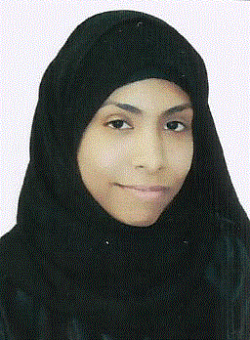

Name: Hawra Hasan Ali Ahmed Ali

Address: Villa 1508, Road 5933, Block 359, Zinj, Bahrain

Nationality: Bahraini

CPR No: 960601759

Birth date: June 8, 1996

Tel.: +973-36374597 / +973-17270591 / +973-36690983

Email: hora_soul@hotmail.com

Marital Status: Single

|  |
| --- |
|  |
| **Abilities and Computer Skills** |

• Aspiration to continually acquire new knowledge to achieve progress.

• Proactive personality.

• Active and Positive behavior under all conceivable circumstances.

• Outgoing and keen to teamwork.

• MS Office (Word, PowerPoint, Excel, and .etc.).

• Booking Systems (Galileo, Amadeus, Saber).

• Advanced Internet Searching and Browsing.

|  |
| --- |
|  |
| **Languages** |

• Arabic (Mother Tongue).

• English.

• Korean.

|  |
| --- |
|  |
| **Education** |

• **2013-2014** Course in Cooking at Jidhafs Center for Social Development

• **2013-2014** Commercial Studies in Jidhafs Secondary School with GPA 71.5%

• **2014-2015** Course in Fashion Designing atJidhafs Center for Social Development

• **2014-2015** Course in English at British Council

• **2017-2018** Diploma in Travel and Tourism Operation with GPA 2.46%

• **2017-2018** FourCourses in Korean Language at King Sejong Institute

|  |
| --- |
|  |
| **Employment Experience** |

  • **2012-2013** Social work at Bilad Al-Qadeem Health Center as Nurse Assistant for 1 month

  • **2014-2015** Worked at Alshaya Company in Victoria's Secret as Sales Associate and Cashier for 5 months

  • **2015-2016** Worked at Alkhalaf International Company in The Smart Fox for video games as part time Cashier for 2 months

  • **2016-2018** Worked at Yousuf Salahuddin Almanzil as Sales Associate for 1 year and 10 months

  • **2017-2018** Member in the Red Crescent Society

|  |
| --- |
| **Hobbies and Interests** |

• Reading

• Drawing

• Singing

• Social work

|  |
| --- |
|  |
| **Reference** |

• Available upon request.